What is massage queue software?

{

Messaging Queue Software is a component that facilitates information exchange between processors, effectively holding messages until they are processed by some component service in a system. They may be used to hold and pass messages in an operating system, within an application, or between computer systems.

}

Used for inter-process communication.

Is a component that is used to exchange information between multiple processors.

It holds the messages until the receiver gets the massage.

Can be use to hold and pass messages in an operating system, within an application or between computer systems.

Importance of using message queue software in software development.

Use to communicate between client and the developer.

In modern software development architectures, there are many small and independent parts of the software developed by different developers or even different companies. Message queue provides communication and coordination for those applications.

Message queues can be used in many ways.

one to one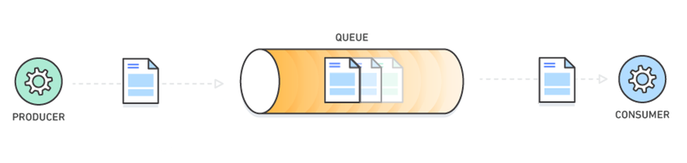

one to many/many to one

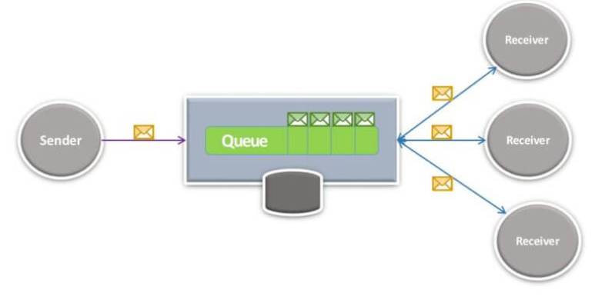

many to many

